

# Table of Content

Table of Content 1

1. **Getting Started** 2

**Getting Github Repository** 2

1. **Logging In** 2

**Creating Profile** 2

**Log In** 3

1. **Dashboard** 4

**Creating Project and Task** 4

**Creating Team** 5

**Chatbot** 5

1. **Team** 6

**View Team members and Task** 6

1. **Repository** 6

**Upload and Download the code** 7

1. **Messages** 7

**Group Chat** 7

**Individual Chat** 8

1. **Calendar** 8

**View Calendar and Deadlines** 8

1. **FAQ** 9
2. **Settings** 9

**Update Profile** 9

**Contact Admin** 10

## **Getting Started**

Welcome to the official user manual of Project Management Tool. This tool is an aid to assist an individual, team or organization to work effectively and organize their tasks and projects. To assist with this user manual,we are also providing a demo and an [Installation Manual](https://github.com/Vamshi399/project_management_tool/blob/master/Project%20Management%20User%20Manual.pdf) for the project so that you user can easily use the application. You can also check Installation Manual to have the instructions for setting the correct environment for the application.

### **Getting Github Repository**

The project management tool works on cross platforms that are Windows or Mac Ubuntu. So for accessing the GitHub repository the user must be able to download or clone the [Project Management Tool Repository](https://github.com/Vamshi399/project_management_tool) by following the instructions given on the GitHub.

## **Logging In**

When the application is started, the user will see a login page where the user can be able to login or register based on the roles. For example, if a person wants to register as a Manager or a team member or a client.

### **Creating Profile**

For creating a profile, the user must provide some credentials such as name email, password, and can select the roles such as Manager,Team member and Client from the drop-down. The user must give a valid email and the password must contain an uppercase letter, one special character and it must be of 8 characters length for the registration purpose. If the details doesn't match with the requirements, the user will not be able to register.

### **Log In**

For login, the user must provide a valid email and correct password which they have used during the registration. If the username and password doesn't match the user will not be able to login.

## **Dashboard**

Dashboard is the main heart of the application where the manager, team member and client will be able to see the project details, progress, assigned team member, status, and the deadlines. The manager will be able to create the project, assign the task and can create the deadlines as well as change the work status and much more. If you login as a team member,then you will be able to see the project name and assigned tasks. If you login as a client, you can only see the project progress.

### **Creating Project and Task**

For creating the project, the user should be logged in as a manager because only the manager will be able to create the project. Here the manager will give the task details, deadline, description and whom it can be assigned to.

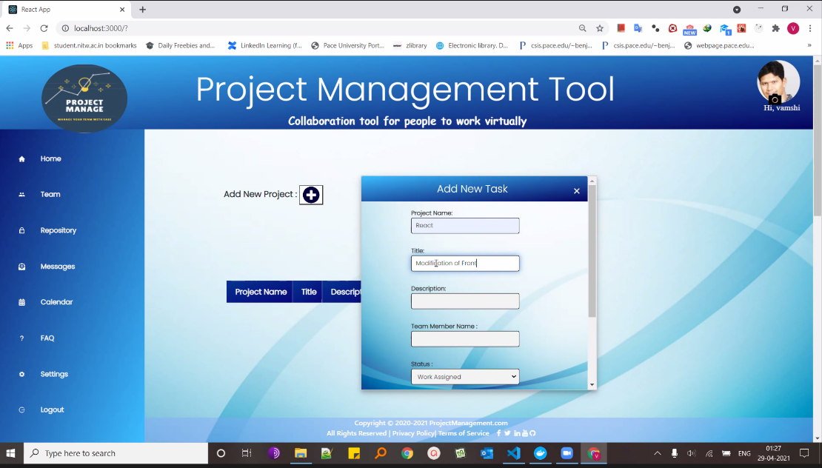

### 

### **Creating Team**

Manager can assign a team member to a project, or task. Team members can get notified when they are added in a team or they can log in to see in which project they have been added. Once the assigned task is completed, the team members can change the status of the task to completed.

### **Chatbot**

Chat bot is the functionality which is available at the right side in the application when a user logs in. In the home screen, when the chat bot is selected there will be a lot of options to choose which includes different links along with the option to contact the admin which makes it user friendly.

## **Team**

When the user clicks on a team, the team members can be able to see what project they have been assigned along with the assigned tasks.They can also update their work status once it's completed.

### **View Team members and Tasks**

The team members can see other team members and the tasks they were assigned to. They can also update the work and status of the task they were assigned to.

## **Repository**

The Repository page contains the source code of the project where the user can upload, share and download the documents. Only the team members and the manager will have access to the repository and only the manager can delete it. The team members can upload their own code and also can download other documents from the repository. When you click on the repository page, it will take you to Google Drive because right now we have access to that only.

### **Upload and Download the code**

The manager and the team members will have the privilege to upload and download the code on the repository. The team members can access other team members code too.

## **Messages**

Communication is the key in any application where a person can communicate with another person to share the status. In our project this can be done in a group chat or an individual chat. Users will be able to chat with each other whereas a manager will have the access to chat with anyone and same with the team members and client. The admin will have the privilege to add the user in a group chat. If a person needs to be added in a group chat,the user will have to request the admin.

### **Group Chat**

In Group chat,the team members can be added in a group and can share a file and send messages. Even the managers and the clients can be added in group chat too.

### **Individual Chat**

Individual chat will provide privilege to every person related to the project and have a one to one conversation related to that project. If a person sends a message to a particular person, it will be directly shown in the other person's page.

## **Calendar**

In calendar, the manager ,team members and client will be able to view the events and assign/see the deadline for the project.

**View Calendar and Deadlines**

Manager can view the events and also assign the deadline to a project or a task whereas the team member will be able to see the events and the assigned task on the calendar along with the deadline, so that they can prioritize the work.

## **FAQ**

For the information about the application you are using or have any questions, you can check the FAQ page .We have updated the FAQ page on the basis of some common questions that can be asked or about the functionality that can be performed. From time to time if any new functionality or question is asked,it will be reflected on the FAQ page.

## **Settings**

In the settings page,you can customize your profile, opt in or out for the notification, contact the admin and upload your profile picture.

### **Update Profile**

In the General section, you can see all the user details. In the Profile section, the user can update the username, password and it will reflect the changes in the application. You can also upload your profile picture and the user name will be displayed under the profile picture. Even if you log out the new changes will be there.

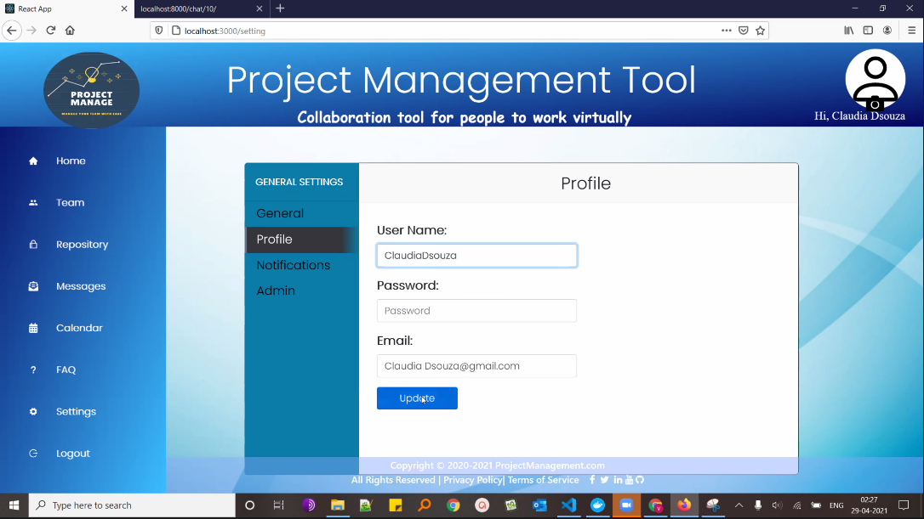

### **Contact Admin**

The contact admin section will allow you to contact the admin by giving your name email and enter the reason in subject and send email to the admin. For example if you want to be added in a group chat you can send your email name along with the message and add the group name to the admin,so that admin can add you in the group chat functionality .

